**By : Ishtiaq Ahmed ( BS – AI GROUP – A )**

**Q1. (Implementation / Logic)**

**ANSWER:**



**Q2. (Dry Run / Trace)**

**ANSWER:**

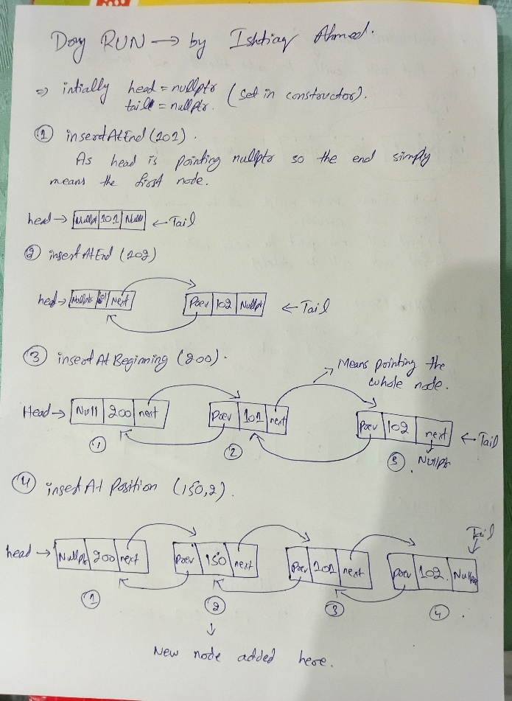

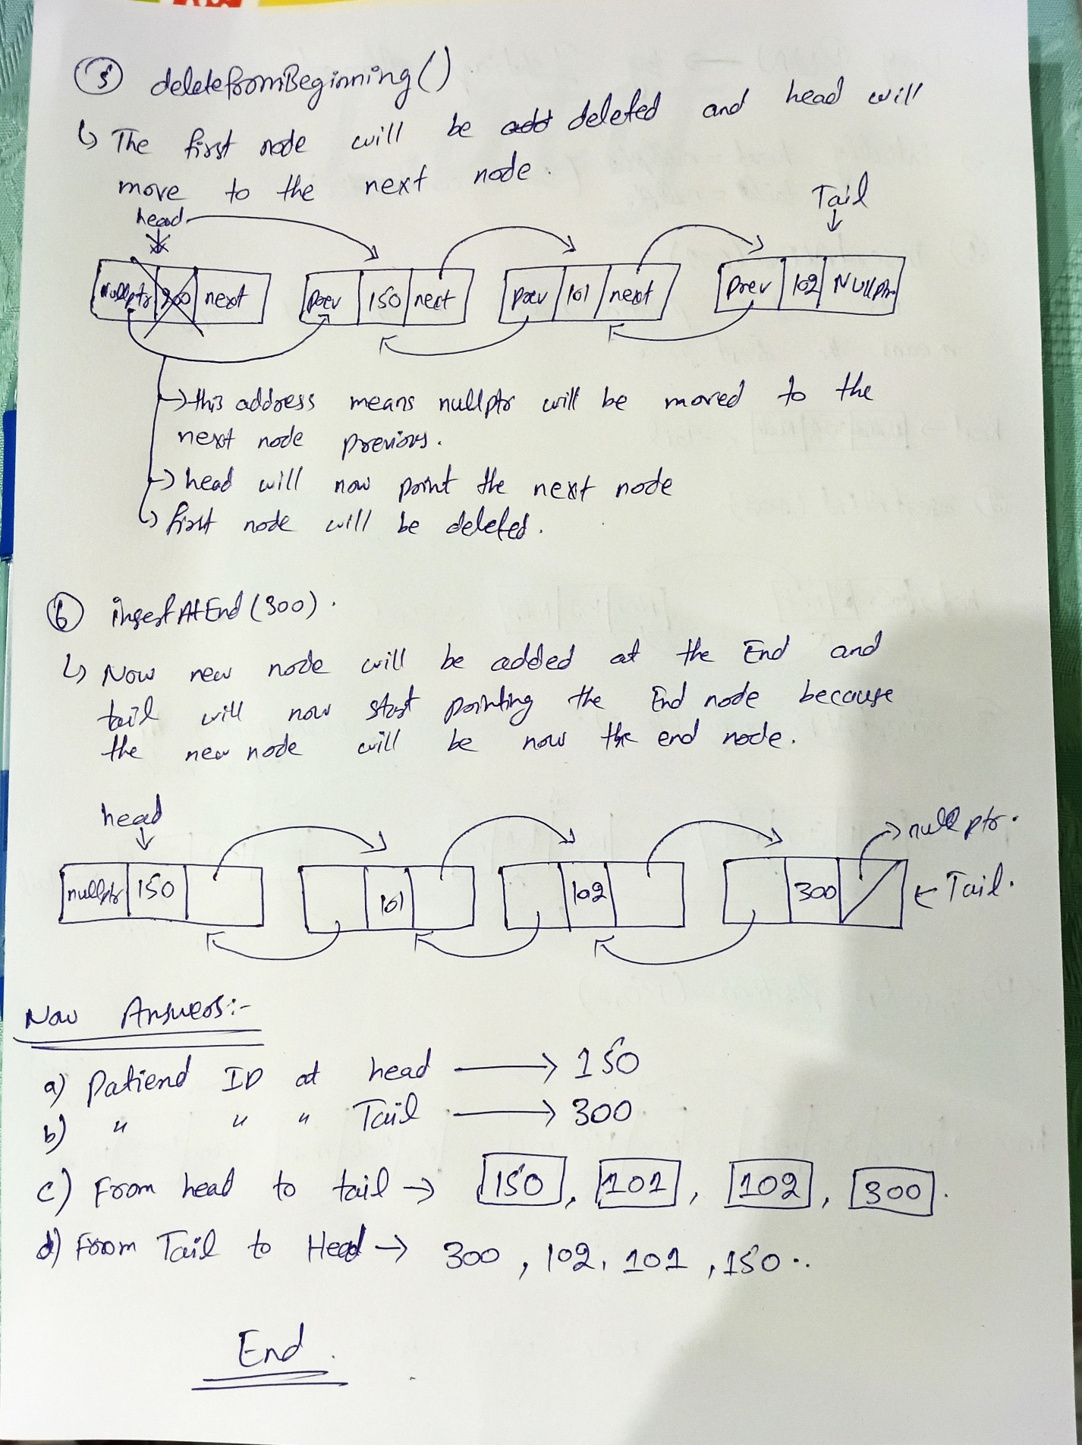  
**Q3. Design the poster  
ANSWER:  
  
  
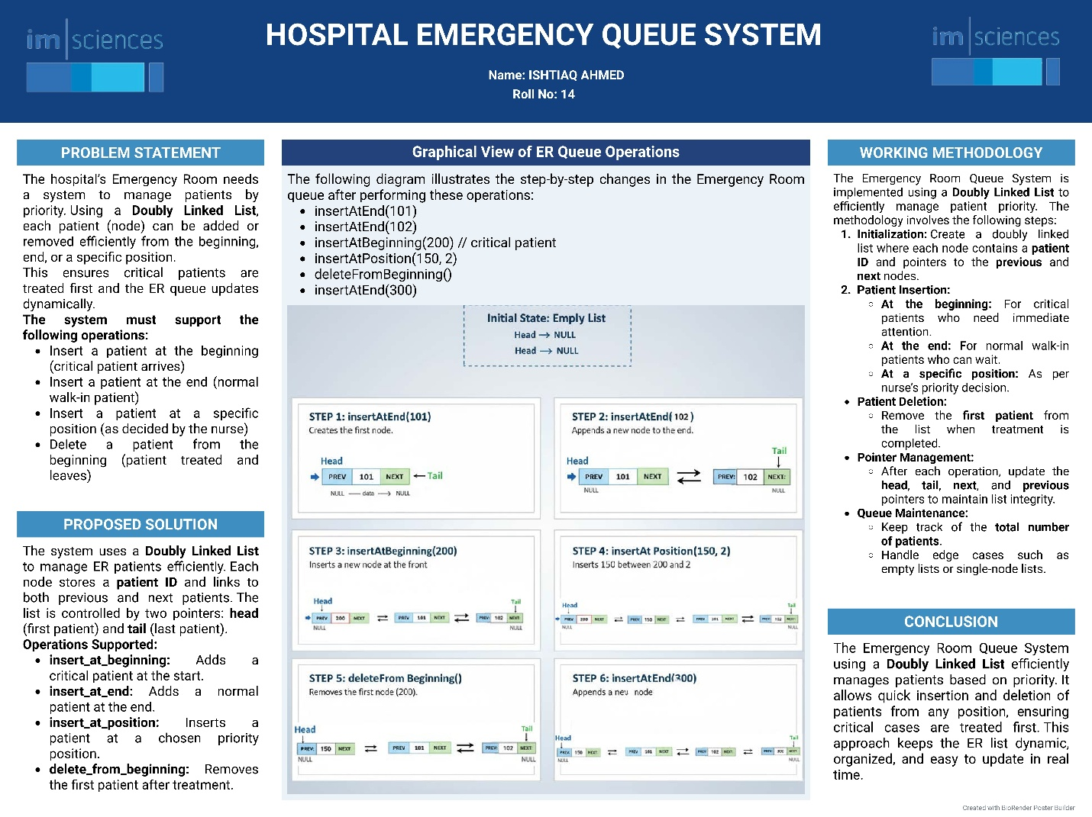**

**WORKING FLOW DIAGRAM**  
